**ANNUAL OPEN MEETINGS ACT RESOLUTION**

**Resolution No. FY 2025-01**

WHEREAS, Section 10-15-1(B) of the Open Meetings Act (hereinafter “OMA”), NMSA 1978, Sections 10-15-1 to -4 (1974, as amended through 2013), states that, except as may otherwise be provided by law, “[a]ll meetings of a quorum of members of any board, commission, administrative adjudicatory body or other policymaking body of any state agency or any agency or authority of any county, municipality, district or political subdivision, held for the purpose of formulating public policy, including the development of personnel policy, rules, regulations or ordinances, discussing public business or taking any action within the authority of or the delegated authority of any board, commission or other policymaking body are declared to be public meetings open to the public at all times”; and

WHEREAS, a public body subject to the Open Meetings Act may hold a meeting to discuss, formulate, or act on public business only after providing reasonable notice to the public; and

WHEREAS, Section 10-15-1(D) of the Open Meetings Act requires all public bodies to determine annually what constitutes reasonable notice for their public meetings; and

WHEREAS, Section 14-4-7.1(B) of the State Rules Act, NMSA 1978, Sections 14-4-1 to -11 (1967, as amended through 2017), identifies the *New Mexico Register* as the official publication for all notices of rulemaking; and

WHEREAS, the Commission of Public Records (the “Commission”) met in an open meeting on May 21, 2024, at 10:00 a.m. to discuss and determine, in part, “what notice for a public meeting is reasonable,” Section 10-15-1(D), given its unique mission, character, and circumstances;

NOW, THEREFORE, BE IT RESOLVED BY THE COMMISSION OF PUBLIC RECORDS:

1. All meetings of the Commission – whether designated as regular, special, or emergency meetings – shall be held as indicated in the notice provided to the public for that meeting.
2. Regular meetings of the Commission shall be held at least four (4) times a year. Notice of regular meetings shall be given at least ten (10) calendar days in advance of the meeting date. Notice of regular meetings shall be, at a minimum, posted online on the New Mexico Commission of Public Records website, posted physically at the State Records Center & Archives, located at 1205 Camino Carlos Rey, Santa Fe, NM 87507, and transmitted (through mail or e-mail) to any broadcast stations licensed by the federal communications commission and newspapers of general circulation that have provided a written request for such notice within the previous twelve (12) months. As required by Section 10-15-1(F), the notice for any regular meeting shall include the date, time, and place of the meeting, as well as either a copy of the agenda or information as to how a copy of the agenda may be obtained.
3. Special meetings of the Commission may be called by the Chair or when requested in writing by any two members of the Commission on a minimum of three calendar day notice. Notice of special meetings shall be, at a minimum, posted online on the New Mexico Commission of Public Records website, posted physically at the State Records Center & Archives, located at 1205 Camino Carlos Rey, Santa Fe, NM 87507, and transmitted (through mail or e-mail) to any broadcast stations licensed by the federal communications commission and newspapers of general circulation that have provided a written request for such notice within the previous twelve (12) months. As required by Section 10-15-1(F), the notice for any special meeting shall include the date, time, and place of the meeting, as well as either a copy of the agenda or information as to how a copy of the agenda may be obtained.
4. At least seventy-two (72) hours before any regular or special meeting, the agenda shall be posted in a prominent physical location and available at the State Records Center & Archives, located at 1205 Camino Carlos Rey, Santa Fe, NM 87507. In addition, the agenda will also be posted online on the New Mexico Commission of Public Records website.
5. As permitted and limited by Section 10-15-1(F), the Commission shall hold emergency meetings only due to “unforeseen circumstances that, if not addressed immediately by the public body, will likely result in injury or damage to persons or property or substantial financial loss” to the Commission. The Commission will avoid emergency meetings whenever possible. Emergency meetings may be called by the Commission Chair or by two members of the Commission upon at least twenty-four (24) hour notice, unless the threat of personal injury, property damage, or substantial financial loss to the Commission requires less notice. As required by Section 10-15-1(F), the notice for any special meeting shall include either a copy of the agenda or information as to how a copy of the agenda may be obtained. Within ten days of holding any emergency meeting or taking action upon any emergency matter, the Commission will notify the New Mexico Office of the Attorney General, except upon the declaration of a state or national emergency.
6. Notice shall be provided to the public at least thirty (30) days in advance of any rulemaking hearing in full conformity with the requirements of the State Rules Act. *See* § 14-4-5.2. In accordance with law, and in the interest of providing the public with access to the greatest possible information about governmental affairs, notices of rulemaking shall be:
   1. posted on the Commission of Public Records website;
   2. posted on the Sunshine Portal;
   3. made available in the agency’s district, field and regional offices, if any;
   4. sent by electronic mail to all persons who have made a written request for notice from the Commission addressing the subject of the rulemaking proceeding and who have provided an electronic mail address to the agency;
   5. sent by electronic mail to persons who have participated in the rulemaking and who have provided an electronic mail address to the agency;
   6. mailed, or at least a modified notice shall be sent containing an internet and street address where the information may be found, in written form to persons who provided a postal address; and
   7. provided to the New Mexico legislative council for distribution to appropriate interim and standing legislative committees.
7. Remote Participation: When it is difficult or impossible for a board member to attend a Board meeting in person, the board member may participate by means of a conference telephone or similar communications equipment as authorized by Section 10-15-1(C).
8. In accordance with the provisions of the Americans With Disabilities Act, and in order to accomplish the Commission’s mission of providing the public with access to the greatest possible information as to its affairs, all notices – for regular, special, and emergency meetings – shall include the following language:

If you are an individual with a disability who is in need of a reader, amplifier, qualified sign language interpreter, or any other form of auxiliary aid or service to attend a meeting or participate in a hearing, please contact the State Records Administrator at (505) 476-7955 at least one week prior to the meeting or as soon as possible. Public documents, including the agenda and minutes, can be provided in various accessible formats. Please contact the State Records Administrator if a summary or other type of accessible format is needed.

1. The Commission may close a meeting or hold an entirely closed meeting only where the subject matter to be discussed is specifically exempt from OMA pursuant to Section 10-15-1(H).
   1. Prior to any closed session taking place during an otherwise-open meeting, closure shall only be permitted upon a majority vote of a quorum taken during open session. The motion to close the meeting must state both the authority for the closed session and the topics to be discussed during the closed session with reasonable specificity. The Commission shall take a roll call vote and the individual vote of each Commissioner shall be recorded in the minutes. While in closed session, only those subjects specified in the motion to close may be discussed. The minutes of the meeting shall reflect whether the matters discussed in the closed meeting were limited only to those specified in the motion to close.
   2. The Commission may hold a closed meeting, separate from an open meeting, provided that appropriate and timely notice is provided to the public, consistent with the OMA requirements for regular, special, or emergency meetings provided herein. The notice must state the specific provision of law authorizing the closed meeting and, additionally, the subjects to be discussed during the closed meeting with reasonable specificity. The minutes of the next open meeting shall reflect whether the matters discussed in the closed meeting were limited only to those specified in the motion to close.
2. The Commission shall review annually the notice provisions of this Resolution and determine whether they constitute reasonable public notice.

This Resolution is hereby ADOPTED by the Commission of Public Records, this 21stday of May, 2024.

**Approved on behalf of the Submitted by:**

**Commission by:**

Robert E. Doucette, Jr., Chair Rick Hendricks, PhD., State Records Administrator

Commission of Public Records State Records Center and Arch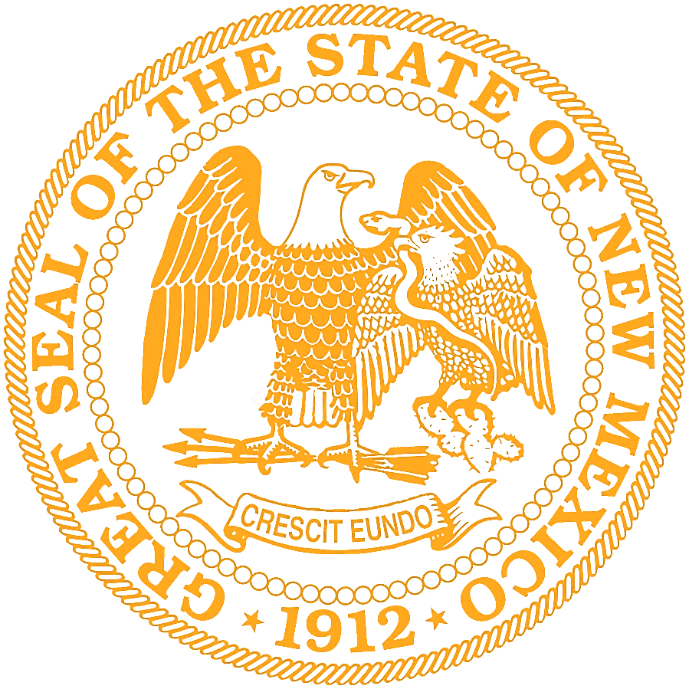ives